Rendering

📘 Definition
# Source: AI Source: Provided by: [Data Path: Persons Table -> ID Column: 1, Name_En Column: Motasem Essam] -> From: [ChatGPT] on [5/2/2026]
Rendering is the process of creating a final image or animation from a 3D scene using computer graphics.
It takes all the scene data (models, lighting, textures, camera, environment) and converts it into a 2D image or video that we can see.

🖥️ How rendering works
# Source: AI Source: Provided by: [Data Path: Persons Table -> ID Column: 1, Name_En Column: Motasem Essam] -> From: [ChatGPT] on [5/2/2026]
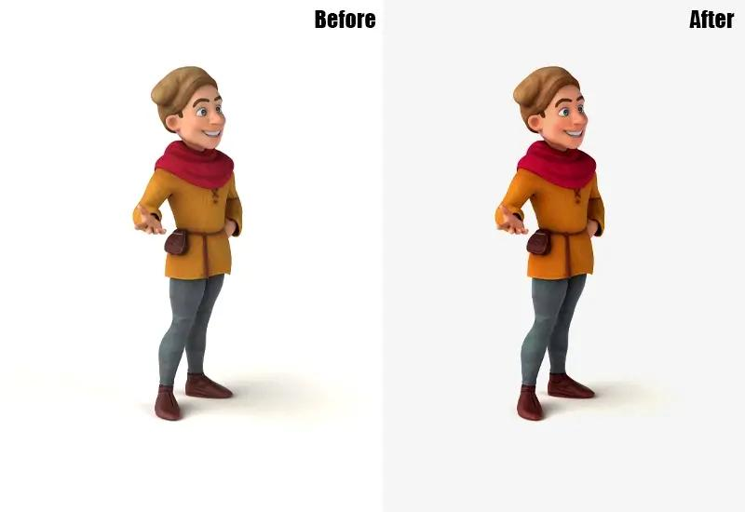
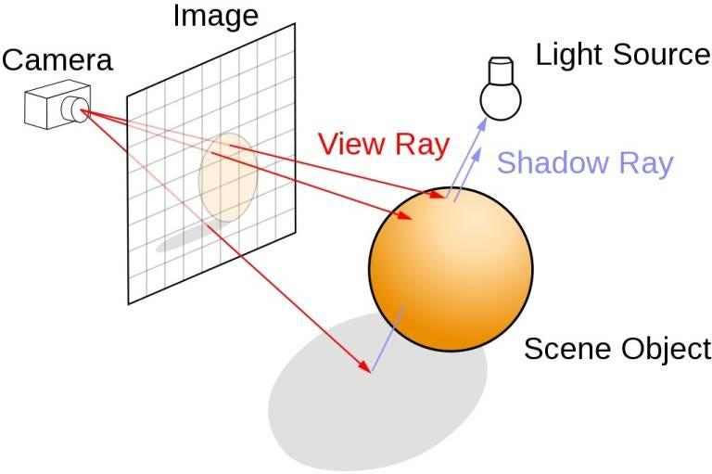
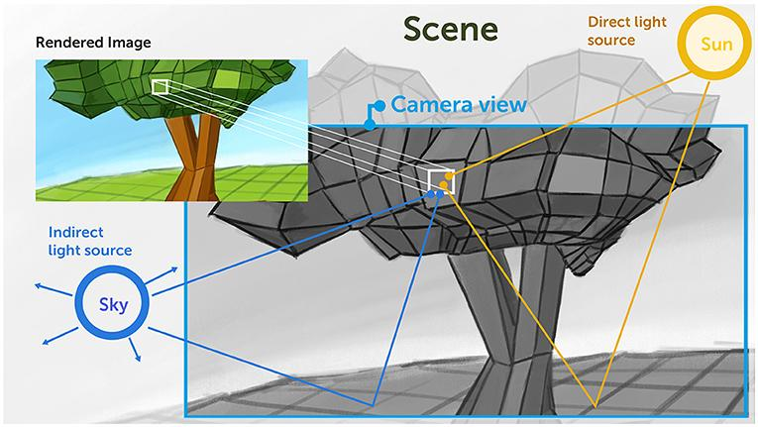
- A 3D scene is created (objects, lights, camera, environment)
- The computer calculates how light interacts with everything
- It applies colors, shadows, textures, and reflections
- The result is a final 2D image or animation frame

🧠 Simple example
# Source: AI Source: Provided by: [Data Path: Persons Table -> ID Column: 1, Name_En Column: Motasem Essam] -> From: [ChatGPT] on [5/2/2026]
Think of:
- 🎬 A movie being filmed → final video is the result
- 🎮 A video game scene → what you see on screen is rendered in real time
- 🖨️ A printer → turns a digital file into a physical image

🎮 Types of rendering
# Source: AI Source: Provided by: [Data Path: Persons Table -> ID Column: 1, Name_En Column: Motasem Essam] -> From: [ChatGPT] on [5/2/2026]
- ⚡ Real-time rendering → used in games (fast, happens instantly)
- 🎬 Offline rendering → used in movies (slow, very high quality)

⚙️ Key features
# Source: AI Source: Provided by: [Data Path: Persons Table -> ID Column: 1, Name_En Column: Motasem Essam] -> From: [ChatGPT] on [5/2/2026]
- 🧩 Converts 3D scenes into 2D images
- 💡 Uses lighting, textures, and shadows
- 🎨 Produces final visual output
- ⏱️ Can be fast (games) or slow (movies)

🚀 In short:
# Source: AI Source: Provided by: [Data Path: Persons Table -> ID Column: 1, Name_En Column: Motasem Essam] -> From: [ChatGPT] on [5/2/2026]
Rendering = the process of turning a 3D scene into a final image or animation using computer calculations.

